***Practical 1***

***LINEX***

SS -1

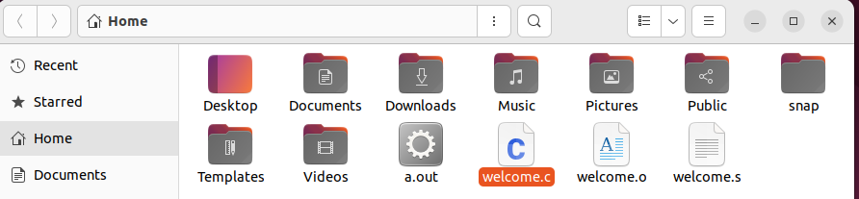

**SS-2**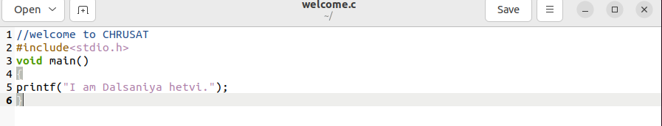

**SS-3**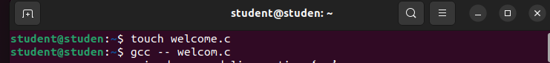

**SS-4**

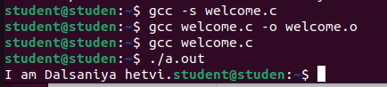

***WINDOSE***

**SS-1**

